**1 . Create a Vector class**

Implement a Vector class that models a 2D vector in geometry.

The class should store two float values: x and y (representing vector components).

It must include:

* A constructor that takes x and y.
* A copy constructor that creates a deep copy of a Vector.
* An overloaded + operator to add two vectors.
* An overloaded = operator to assign one vector to another.

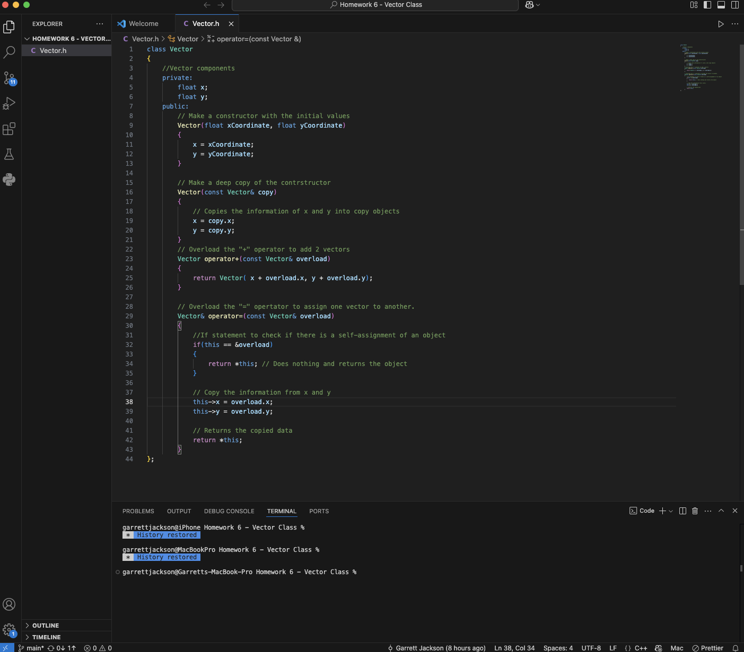

class Vector

{

//Vector components

private:

float x;

float y;

public:

// Make a constructor with the initial values

Vector(float xCoordinate, float yCoordinate)

{

x = xCoordinate;

y = yCoordinate;

}

// Make a deep copy of the contrstructor

Vector(const Vector& copy)

{

// Copies the information of x and y into copy objects

x = copy.x;

y = copy.y;

}

// Overload the "+" operator to add 2 vectors

Vector operator+(const Vector& overload)

{

return Vector( x + overload.x, y + overload.y);

}

// Overload the "=" opertator to assign one vector to another.

Vector& operator=(const Vector& overload)

{

//If statement to check if there is a self-assignment of an object

if(this == &overload)

{

return *this; // Does nothing and returns the object

}

// Copy the information from x and y

this->x = overload.x;

this->y = overload.y;

// Returns the copied data

return *this;

}

};